Step 1: Open the lab link to access the Kali machine.
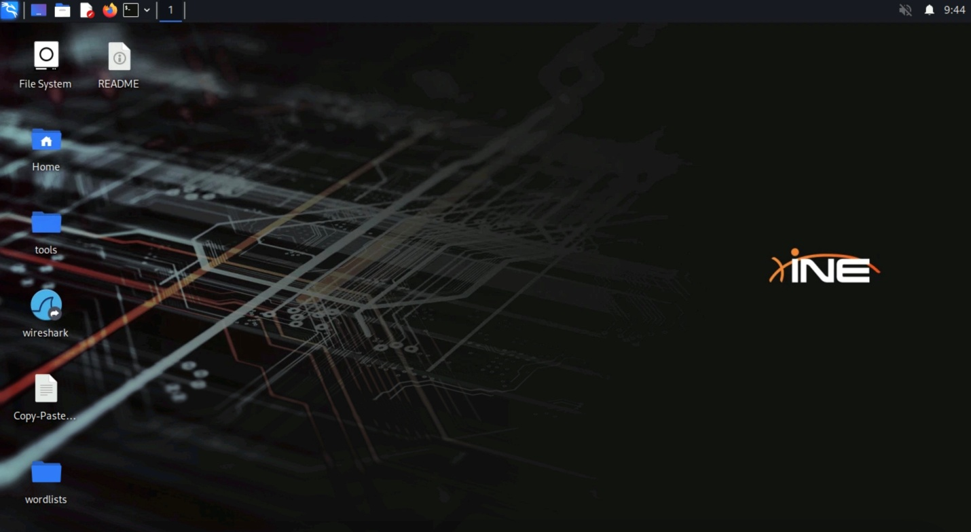
Step 2: What is the SMTP server name and banner.
Answer:
Server: Postfix
Banner: openmailbox.xyz ESMTP Postfix: Welcome to our mail server.
Command:
nmap -sV -script banner demo.ine.local
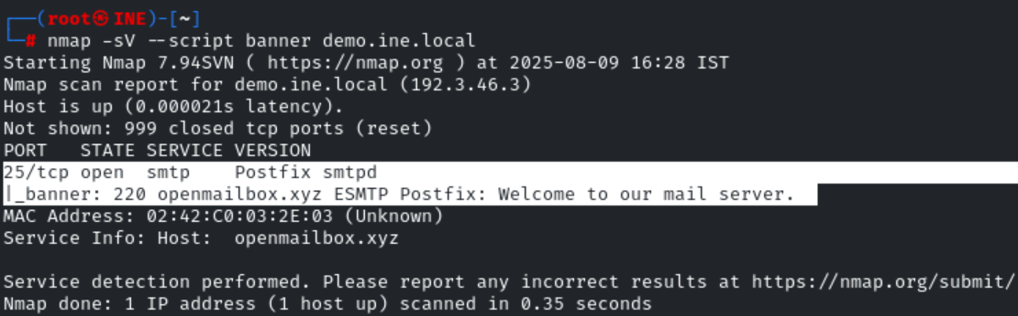

Step 3: Connect to SMTP service using netcat and retrieve the hostname of the server (domain name).
Netcat (nc) is used to send and receive data over network connections using TCP or UDP.
It’s often used for debugging, file transfers, and creating reverse or bind shells.
Answer:
openmailbox.xyz
Command:
nc demo.ine.local 25
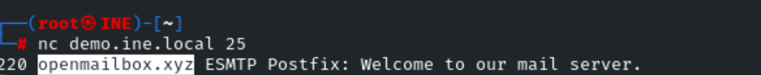

Step 4: Does user "admin" exist on the server machine? Connect to SMTP service using netcat and check manually.
Answer:
Yes
Command:
VRFY admin@openmailbox.xyz
VRFY admin@openmailbox.xyz is an SMTP command that asks the mail server to verify if the email address admin@openmailbox.xyz exists.
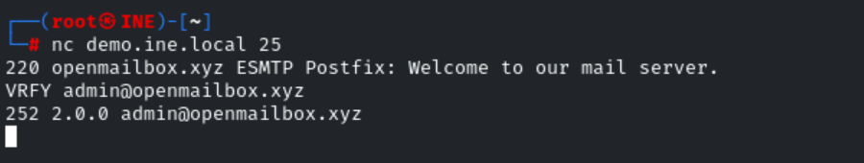

Step 5: Does user "commander" exist on the server machine? Connect to SMTP service using netcat and check manually.
Answer:
No
Command:
VRFY commander@openmailbox.xyz

Step 6: What commands can be used to check the supported commands/capabilities? Connect to SMTP service using telnet and check.
Commands:
telnet demo.ine.local 25
HELO attacker.xyz
EHLO attacker.xyz
HELO attacker.xyz → Identifies yourself to the mail server (basic greeting). You send your domain or hostname after HELO.
EHLO attacker.xyz → Same as HELO, but it’s the Extended HELO used in ESMTP (Extended SMTP) and tells the server you support/enabled extra features like authentication, TLS, etc.
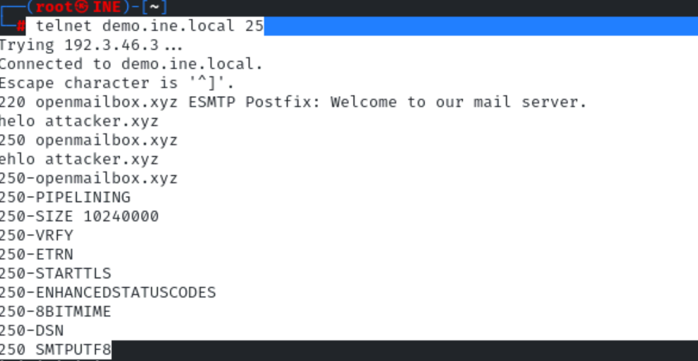
In short: You connected to an SMTP server, greeted it, and it told you what features it supports.
Step 7: How many of the common usernames present in the dictionary /usr/share/commix/src/txt/usernames.txt exist on the server. Use smtp-user-enum tool for this task.
Answer:
8
Command:
smtp-user-enum -U /usr/share/commix/src/txt/usernames.txt -t demo.ine.local

smtp-user-enum to check which usernames from /usr/share/commix/src/txt/usernames.txt exist on the SMTP server demo.ine.local.
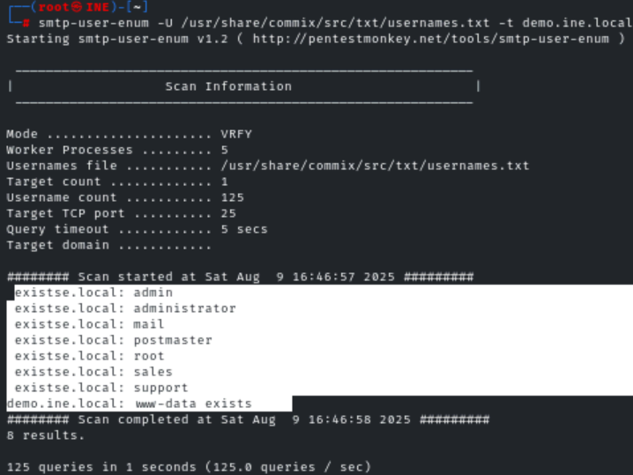

Step 8: How many common usernames present in the dictionary /usr/share/metasploit-framework/data/wordlists/unix_users.txt exist on the server. Use suitable metasploit module for this task.
Answer:
22
Commands:
msfconsole -q
use auxiliary/scanner/smtp/smtp_enum
set RHOSTS demo.ine.local
exploit
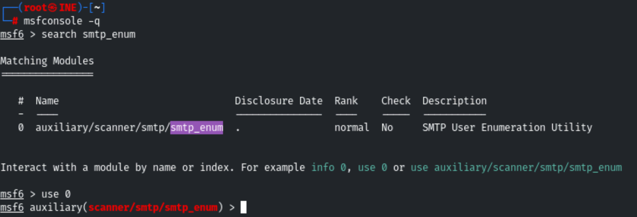
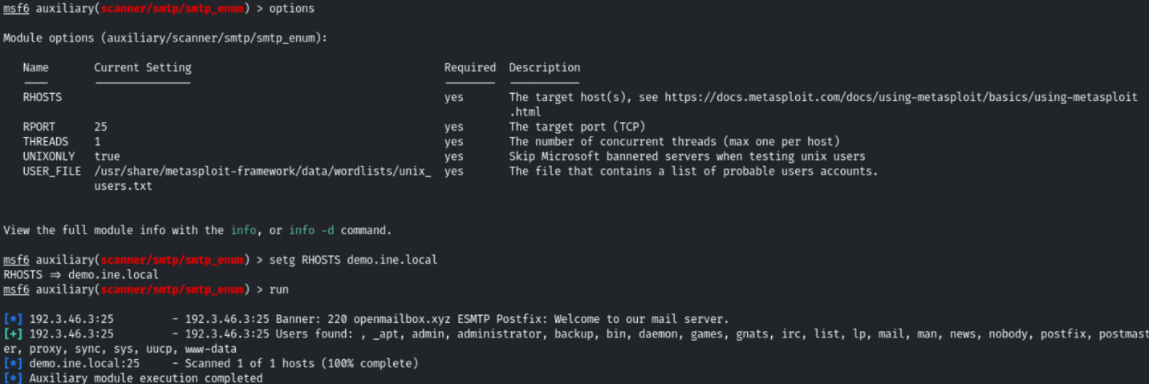

Step 9: Connect to SMTP service using telnet and send a fake mail to root user.
Commands:
telnet demo.ine.local 25
HELO attacker.xyz
mail from: admin@attacker.xyz
rcpt to:root@openmailbox.xyz
data
Subject: Hi Root
Hello,
This is a fake mail sent using telnet command.
From,
Admin
.
- telnet demo.ine.local 25 → Connect to the SMTP server on port 25.
- HELO attacker.xyz → Identify yourself to the server.
- mail from: admin@attacker.xyz → Set the sender email address.
- rcpt to: root@openmailbox.xyz → Set the recipient email address.
- data → Tell the server you’re starting the message body.
- Message content (Subject + body) → The actual email.
- . (single dot on a line) → Ends the message body and sends it.

Note: There is a dot(.) in the last line which indicates the termination of data.
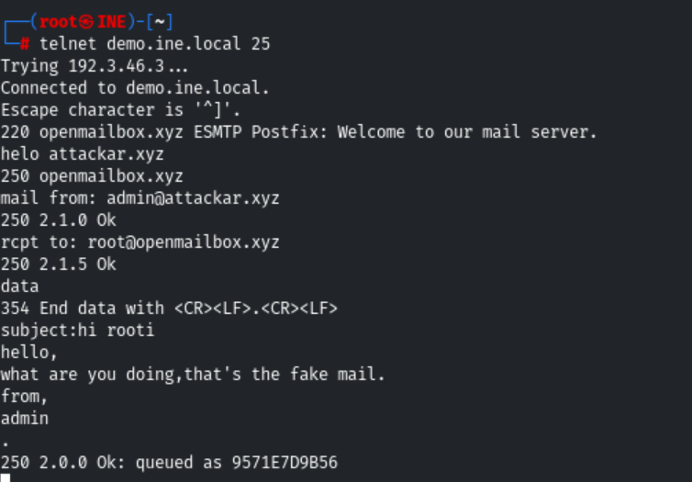

Step 10: Send a fake mail to root user using sendemail command.
Command:
sendemail -f admin@attacker.xyz -t root@openmailbox.xyz -s demo.ine.local -u Fakemail -m "Hi root, a fake from admin" -o tls=no

- -f admin@attacker.xyz → Sender address.
- -t root@openmailbox.xyz → Recipient address.
- -s demo.ine.local → SMTP server to use.
- -u Fakemail → Email subject.
- -m "Hi root, a fake from admin" → Email body.
- -o tls=no → Don’t use TLS encryption.

